
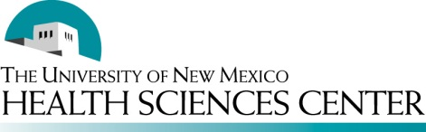
Best Practices for Conducting Health Disparities Research With and Across Diverse Communities
in New Mexico

Based on principles of Intercultural Communication/Leadership and Community-Based Participatory Research, the NM CARES seeks to foster institutional reflection and change and cultivate partnerships and capacities for UNM to conduct health disparities research with and across diverse communities in New Mexico. The Guiding Framework (see below) depicts how the needed community and institutional changes can happen to overcome contextual barriers (discrimination, socio-economic inequity) when the research relationship and process are built upon principles of Intercultural Partnership and CBPR. Using this framework as a basis for engaging with communities, the NM CARES HD (Community Engagement Core) will be identifying and contacting academic and community partners to become Intercultural Health Disparity Scholars.

Intercultural Health Disparity (IHD) Scholars will be comprised of academic researchers, students and other community members (clinicians/providers, community members, traditional healers and local, state, and tribal policy makers) who are committed to conducting research aimed at eliminating health disparities. IHD Scholars will be selected for their commitment to eliminating health disparities; fostering cross-cultural relationships; and interest in, and need for, developing intervention models that bridge community based knowledge with empirical evidence. IHD Scholar teams we will be recruited from four communities in 2011:

- Apache Nation (Mescalero)
- NM Border area (Southern Colonias, Las Cruces, Deming, Lordsburg & Silver City)
- Navajo Nation (Shiprock region)
- Albuquerque metro-area (South Valley & Southeast Heights)

From May to December 2011, a series of community-based dialogues and co-learning institutes will be initiated with community-academic partners interested in or currently conducting health disparities research in the four geographically diverse areas above. The goals of these community engagement activities are to:

- Facilitate cross-cultural dialogue and creative conflict resolution for conducting research with and across diverse communities in New Mexico;
- Understand and employ Community-Based Participatory Research methodologies;
- Build research capacities to bridge cultural and indigenous knowledge and practices with empirically supported theories and interventions; and
- Address research gaps and foster innovation and best practices to address and eliminate health disparities.

Today’s module on Historical Trauma Theory and Intervention Research presented by Dr. Maria Yellow Horse Brave Heart addresses Goal #3 and is intended to introduce key concepts needed to bridge indigenous ways of knowing with western empirical epistemologies. Dr. Brave Heart introduces the concept of Historical Trauma and its impact on the health of American Indian/Alaska Native children, youth and their parents. She also provides an overview of the Historical Trauma Unresolved Grief Intervention (HTUG) as an approach to addressing intergenerational massive group trauma healing.

Guiding Framework for Conducting Health Disparities Research with Communities in New Mexico
INTERCULTURAL CBPR MODEL
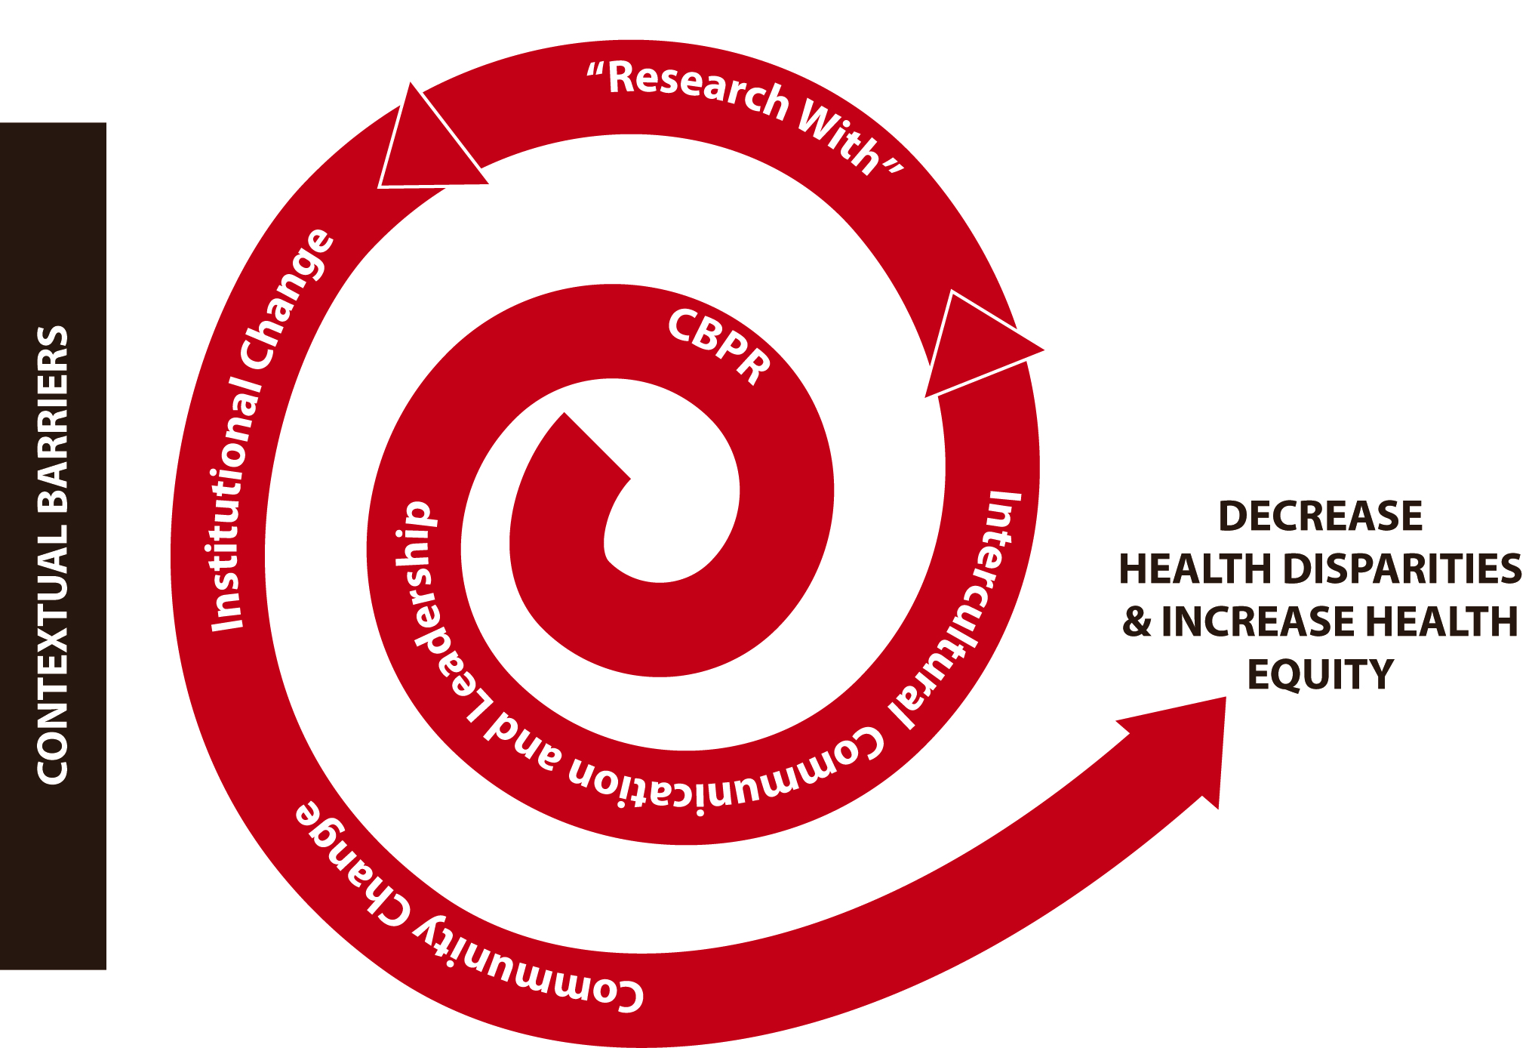

Contextual Barriers
- Socioeconomic inequity
- Racial/ethnic discrimination
- Inconsistent and disparate health care delivery
- Rural isolation and inadequate transportation
- Time required to translate research findings into practice

PRINCIPLES OF COMMUNITY BASED PARTICIPATORY RESEARCH
CBPR is described as supporting “collaborative, equitable partnerships in all phases of the research.” This is achieved through a “co-learning and capacity building” process among all partners.” All research findings and knowledge gained is disseminated to all partners. CBPR involves a “long-term process and commitment.”
Source: Israel et al. 2003, pp. 56-58

- Cultivate sustainable partnerships
- Cooperate and collaborate
- Foster bi-directional learning and reciprocal knowledge
- Incorporate community theories into research
- Develop interventions for diverse communities
- Create new systems and build local capacities
- Disseminate research and knowledge to all partners
- Commit to long term community relationships, research and action
- Redress power imbalances
- Increase health equity
Source: Wallerstein and Duran 2009:e1-e6

This model was developed by the Community Engagement Core, New Mexico Center for Advancement of Research, Engagement & Science on Health Disparities, University of New Mexico Health Sciences Center (11/05/2010).
For more information call (505) 272-3876, email lcacari-stone@salud.unm.edu or see http://hsc.unm.edu/programs/nmcareshd/mission_goals.shtml

Tribal Participatory (TPR):
- Seek tribal government approval for research, publication, dissemination
- Return data to the tribe
- Promote core values: trust, respect, self-determination, mutuality of interests, reciprocity
Source: Mason et al. 2004/Norton & Manson 1996

Intercultural Communication and Leadership
- Include cultural diversity at the center of how things are conceptualized and implemented across research projects.
- Expand the definition of community and research partners to Intercultural Allies who mutually advocate for each other to guarantee community voice and perspective in the outcomes relating to the elimination of health disparities.
- Be aware of power differentials between community experts and the research institution.
- Both partners step into a mediator role “for the community but not against the institution.”
- Engage in intercultural communication based on:

Mutuality ⬄ Respect ⬄ Reciprocity ⬄ Authenticity ⬄ Trust ⬄ Collaboration
Source: Chené 2010

RESEARCH WITH COMMUNITIES
In order to move towards institutional and community change, dialogues between academic and community members are needed. The focus of the on-going dialogues should be on “how” we shift our thinking about doing community research from using an “on/in” approach to a “with” modality. The figure below illustrates a continuum of research that occurs between university’s and communities from doing research on, to in to with.
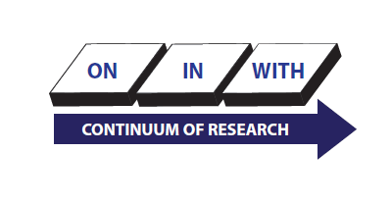
ANTICIPATED OUTCOMES
This framework guides the way for the institution and communities to work together and conduct mutually beneficial research that Reduces Health Disparities and Increases in Health Equity.

